**Charotar University of Science and Technology [CHARUSAT]**

**Chandubhai S. Patel Institute of Technology [CSPIT]**

**U & P U. Patel Department of Computer Engineering**

**Lab Manual**

|  |  |  |  |  |  |  |  |  |
| --- | --- | --- | --- | --- | --- | --- | --- | --- |
| Subject code | : | CE-350 | Semester | : | 6 | Academic Year | : | 2021 |
| Subject name | : | Data Warehouse and Data Mining | | | | | | |

**Practical – 4**

**Aim:**

**Perform Different Data Mining Activities using Weka Explorer Tool, Weka Experimenter and Knowledge Flow (Open Source Data Mining Tool).**

* **Prerequisite**

S/W: - Weka Tool

Little bit knowledge about the Weka tool and how it works on Data Mining.

* **Step to install Weka Tool:**

**#1)**Download the software from **chrome browser.**

Check the configuration of the computer system and download the stable version of WEKA (currently 3.8) from this page.

[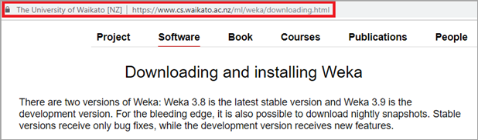](https://www.softwaretestinghelp.com/wp-content/qa/uploads/2020/07/Download-and-Installation-of-WEKA-1.png)

**#2)**After successful download, open the file location and double click on the downloaded file. The Step Up wizard will appear. Click on Next.

[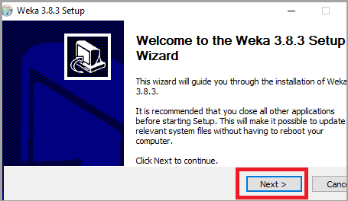](https://www.softwaretestinghelp.com/wp-content/qa/uploads/2020/07/Step-Up-wizard-1.png)

**#3)**The License Agreement terms will open. Read it thoroughly and click on “I Agree”.

[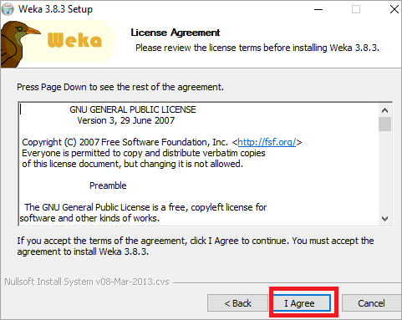](https://www.softwaretestinghelp.com/wp-content/qa/uploads/2020/07/The-License-Agreement-Terms.png)

**#4)**According to your requirements, select the components to be installed. Full component installation is recommended. Click on Next.

[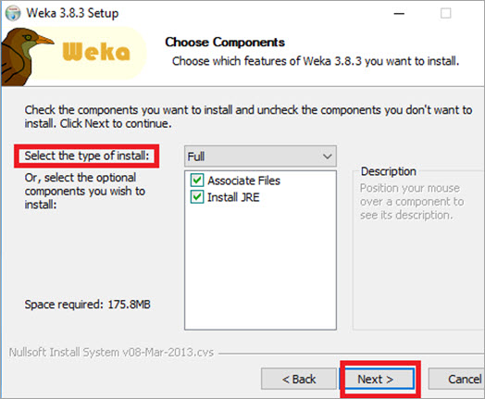](https://www.softwaretestinghelp.com/wp-content/qa/uploads/2020/07/select-the-components-to-be-installed.jpg)

**#5)**Select the destination folder and Click on Next.

[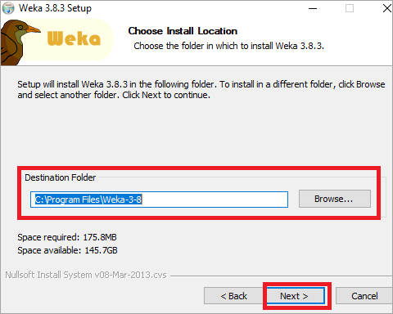](https://www.softwaretestinghelp.com/wp-content/qa/uploads/2020/07/destination-folder.png)

**#6)**Then, Installation will start.

[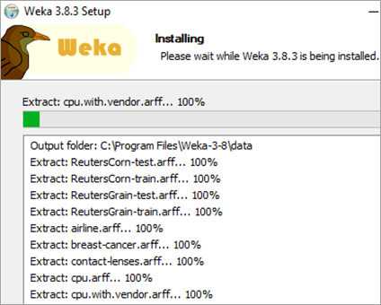](https://www.softwaretestinghelp.com/wp-content/qa/uploads/2020/07/Installation-Window.png)

**#7)**If Java is not installed in the system, it will install Java first.

[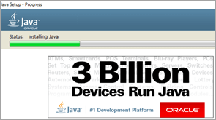](https://www.softwaretestinghelp.com/wp-content/qa/uploads/2020/07/Java-1.png)

**#8)**After the installation is complete, the following window will appear. Click on Next.

[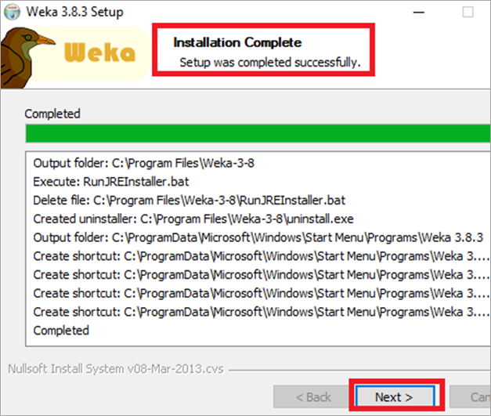](https://www.softwaretestinghelp.com/wp-content/qa/uploads/2020/07/Installation-Complete-Window.png)

**#9)**Select the Start Weka checkbox. Click on Finish.

[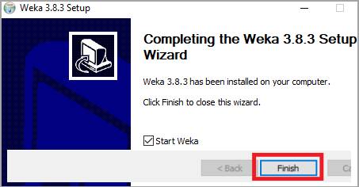](https://www.softwaretestinghelp.com/wp-content/qa/uploads/2020/07/Explorer-Opens-1.png)

**#10)**WEKA Tool and Explorer window opens.

[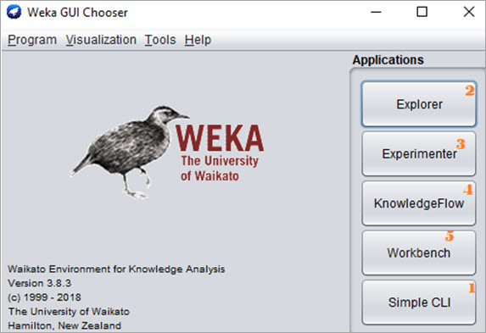](https://www.softwaretestinghelp.com/wp-content/qa/uploads/2020/07/WEKA-Tool-and-Explorer.jpg)

* **Screenshot of Weka Explorer:**

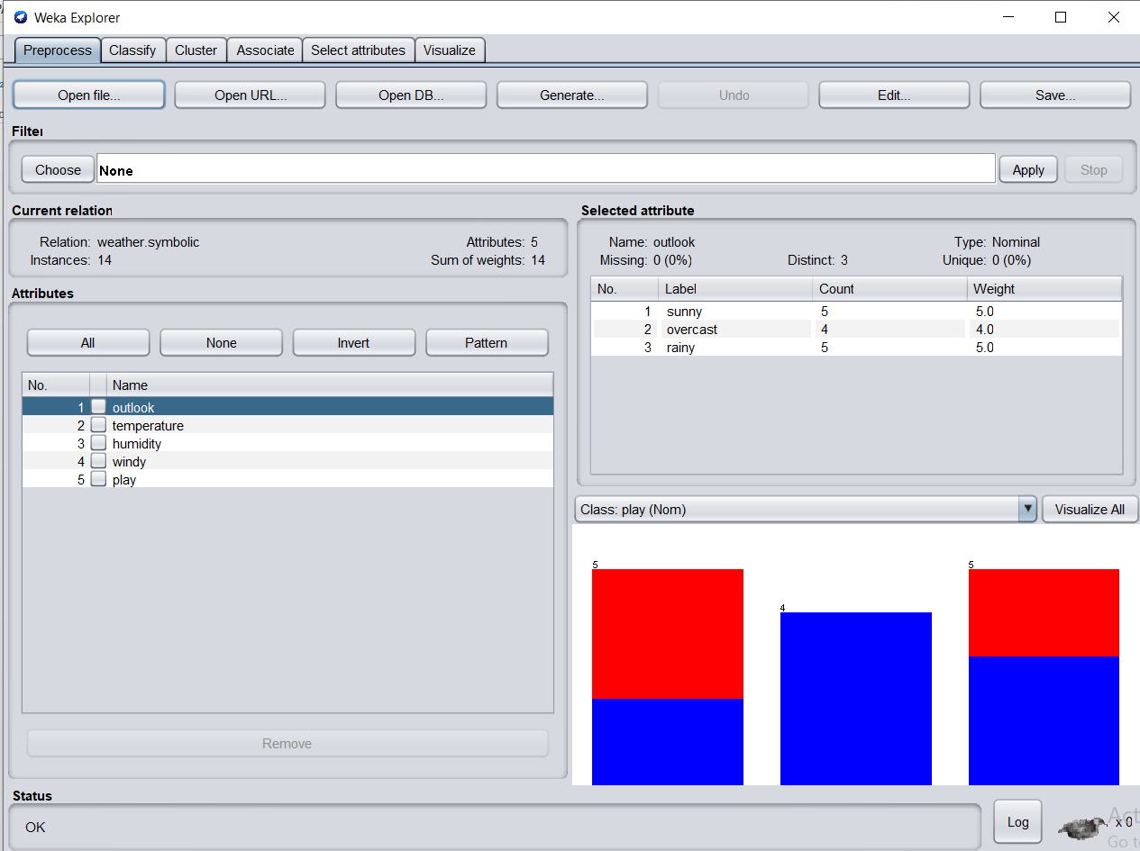

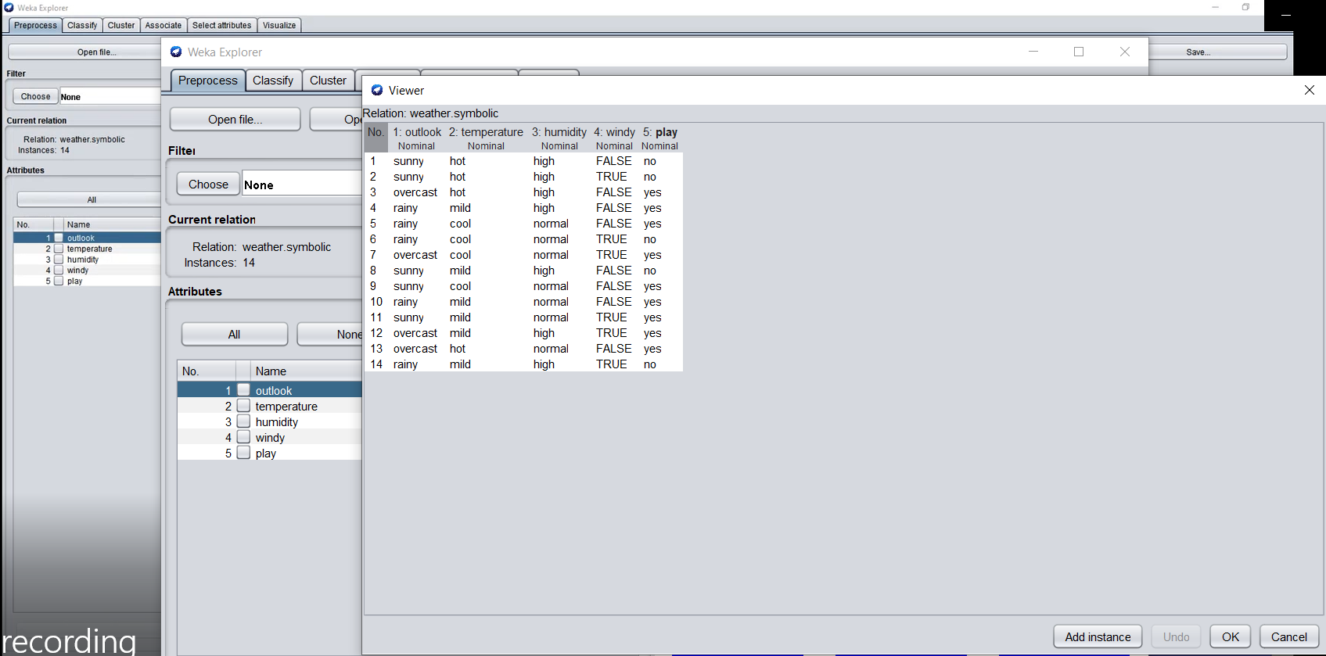

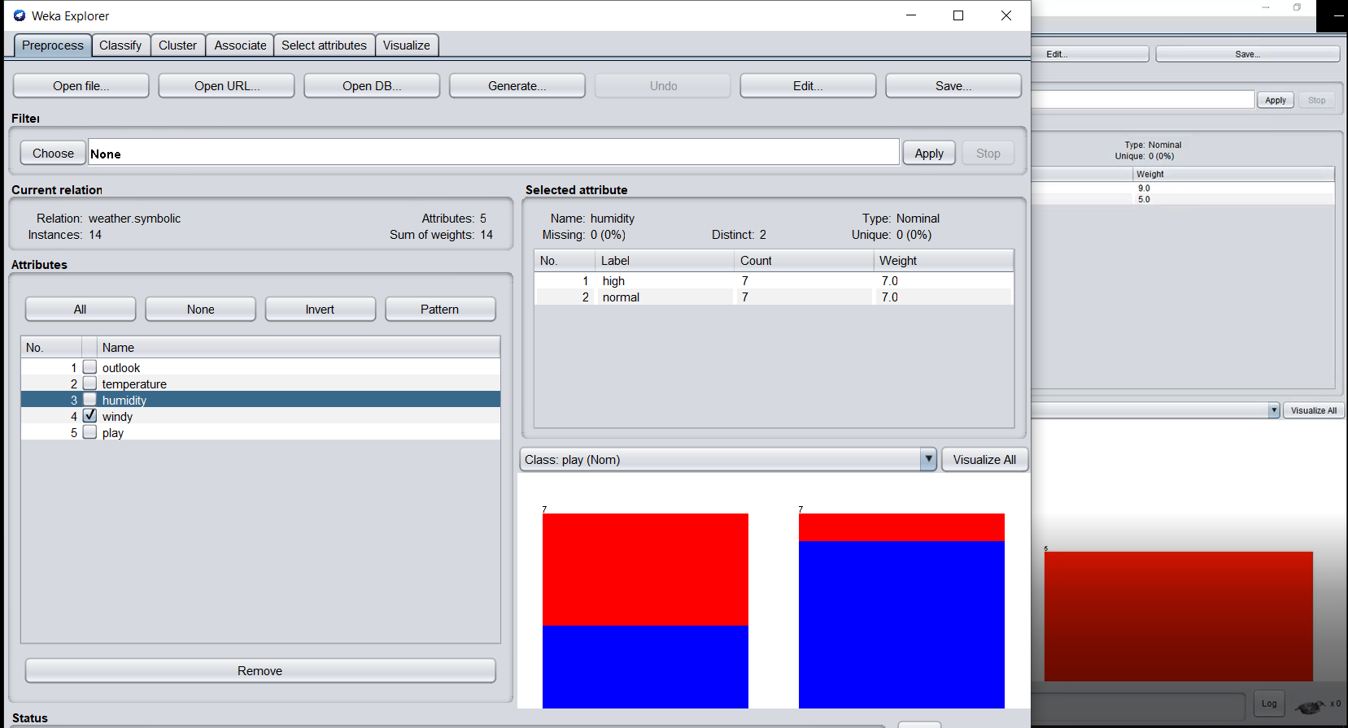

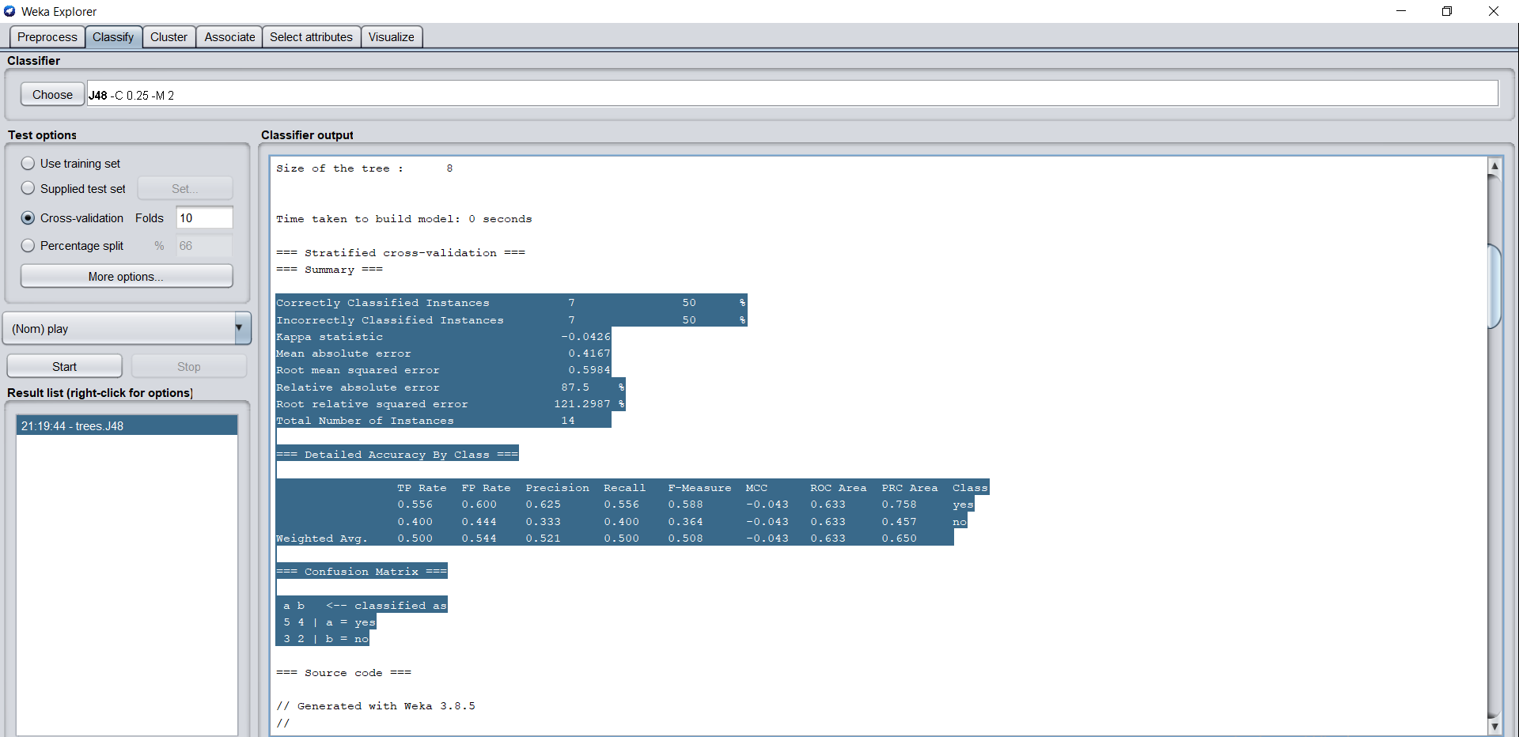

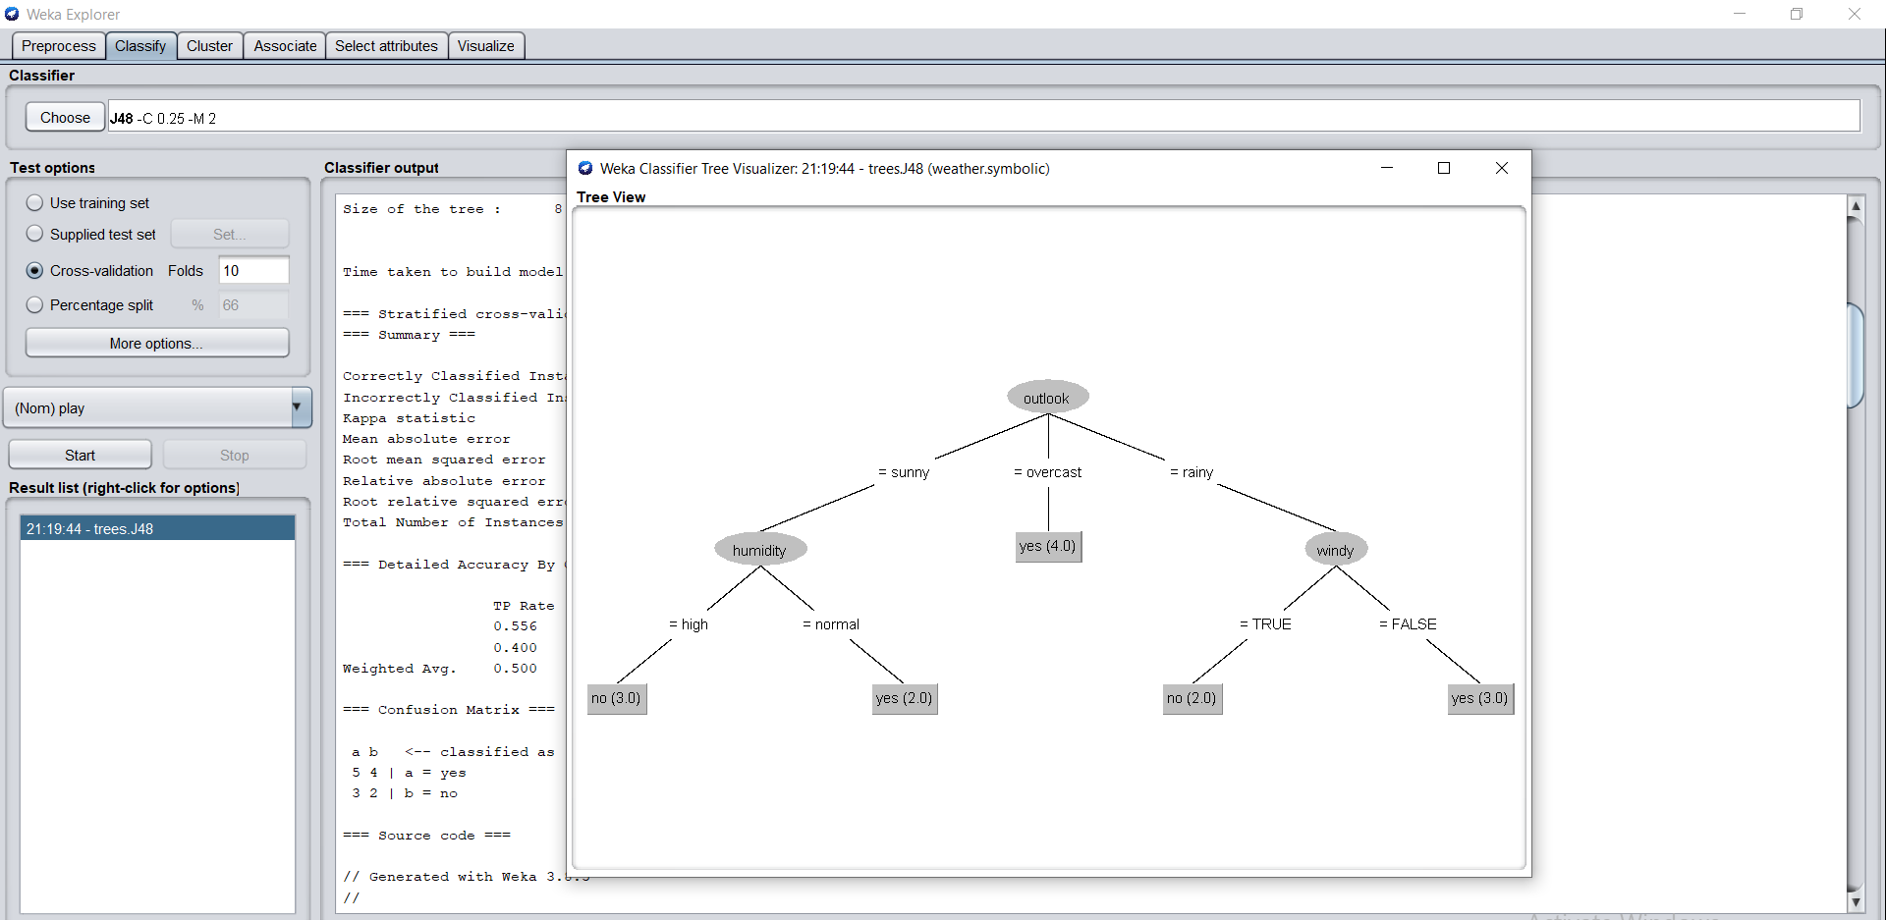

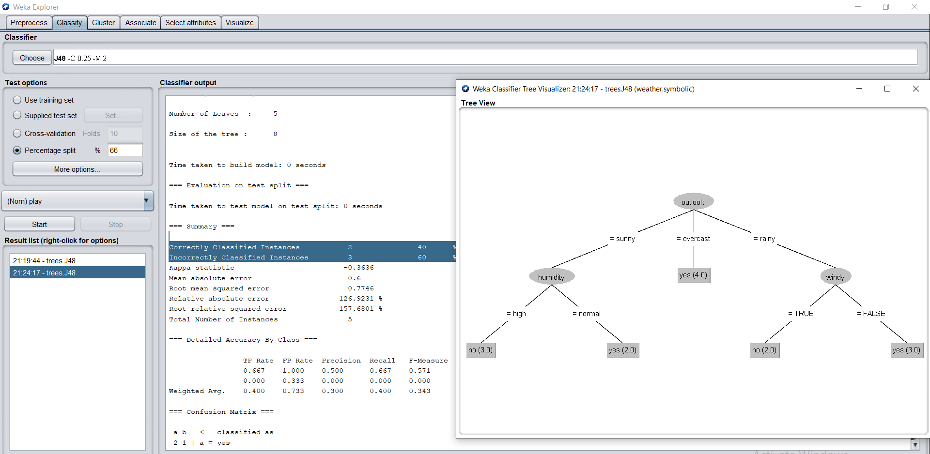

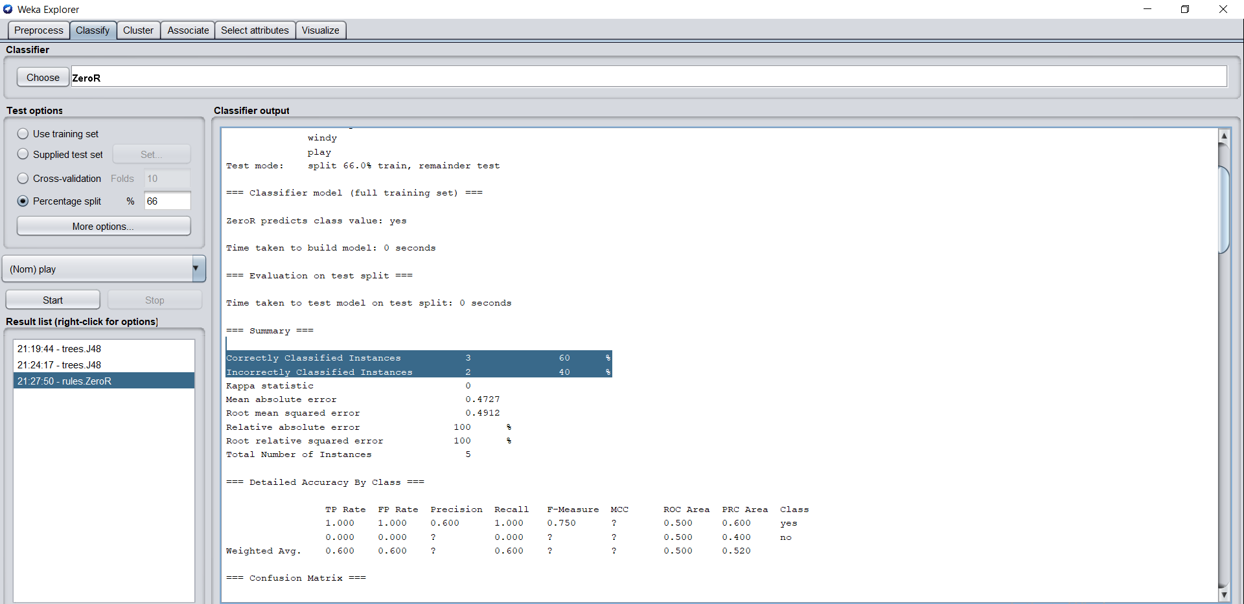

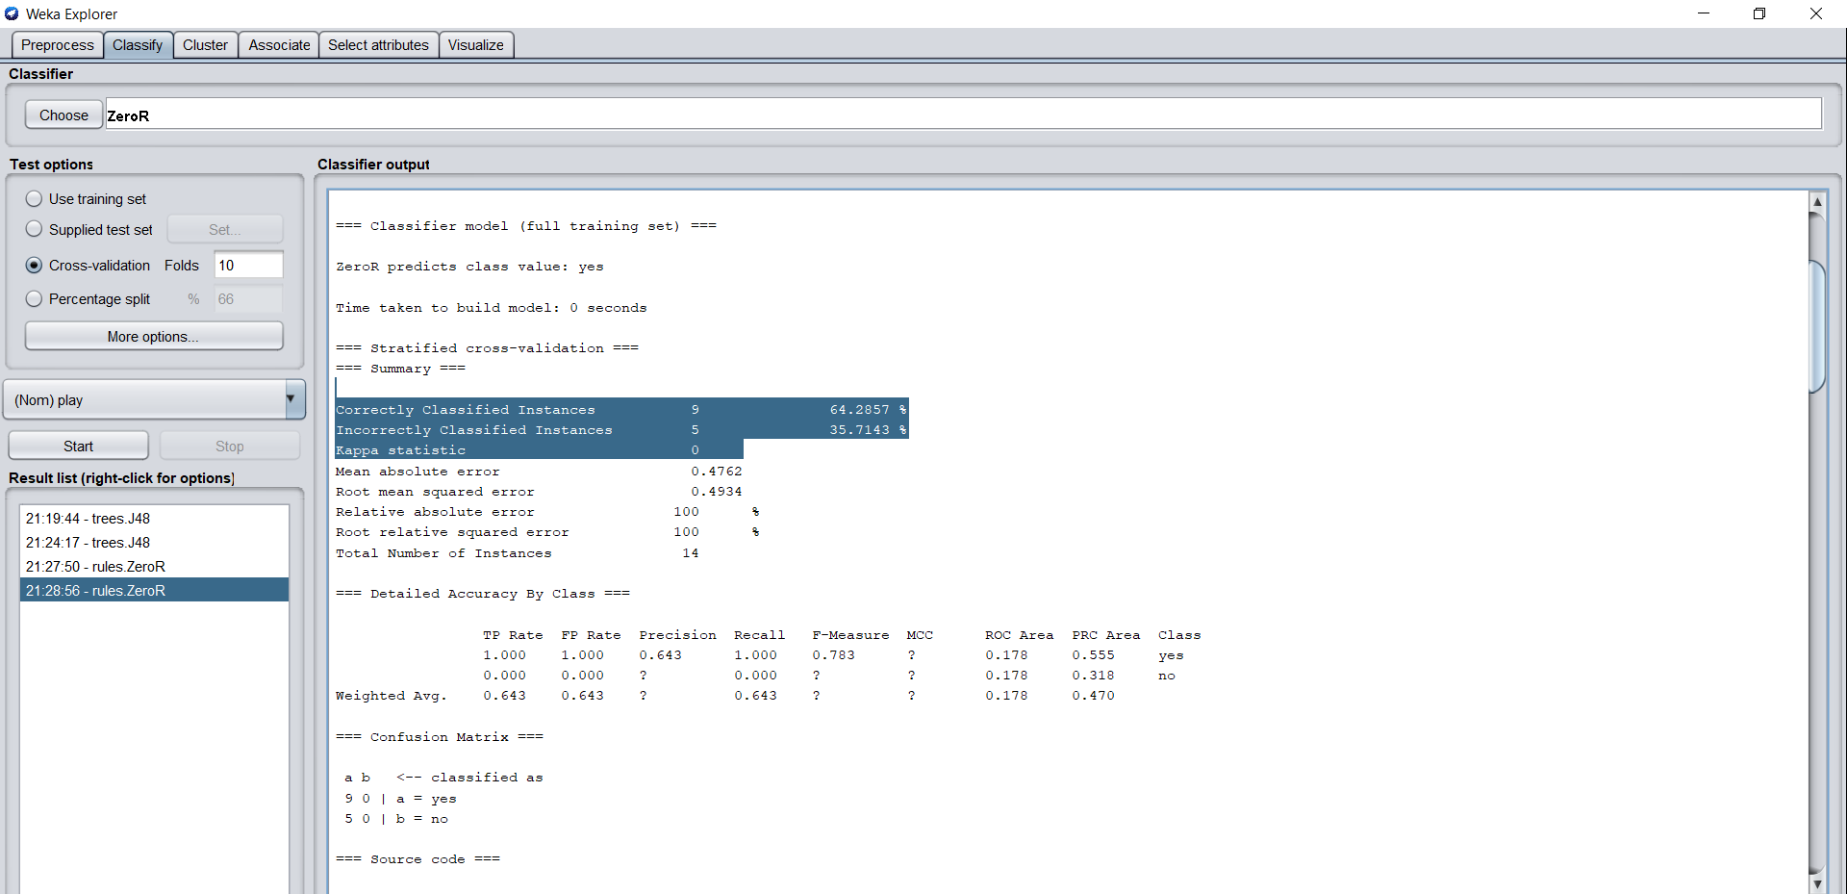

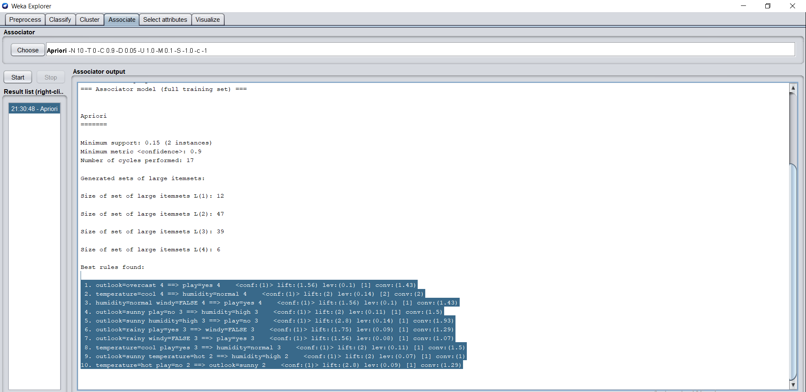

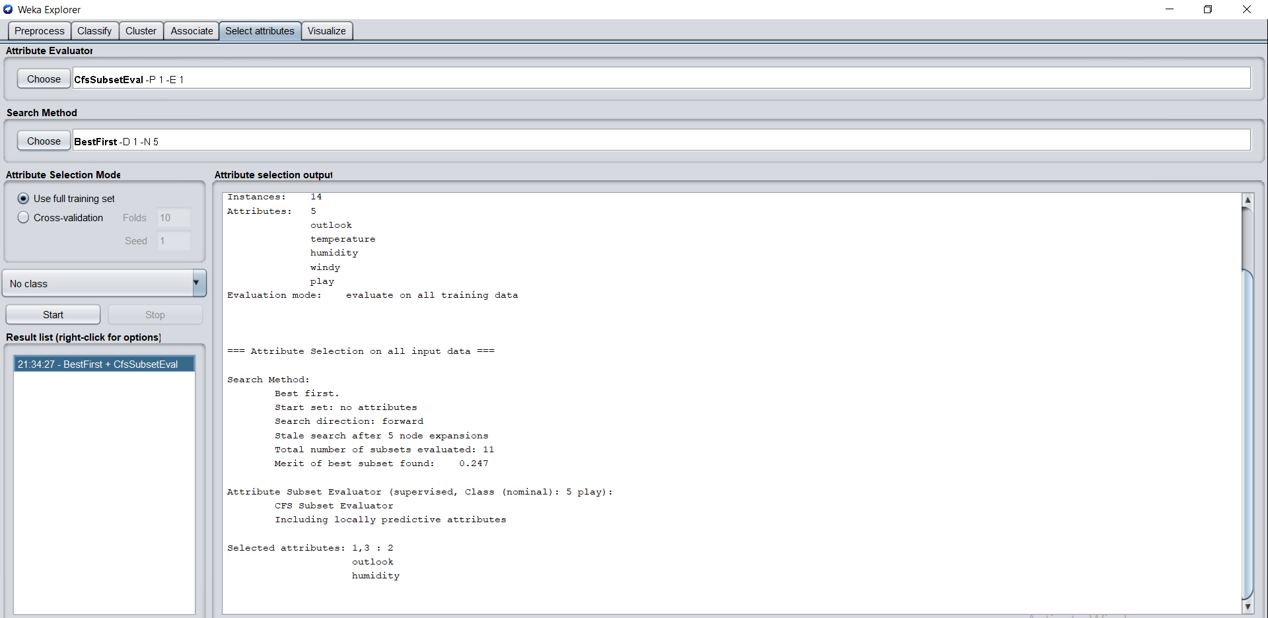

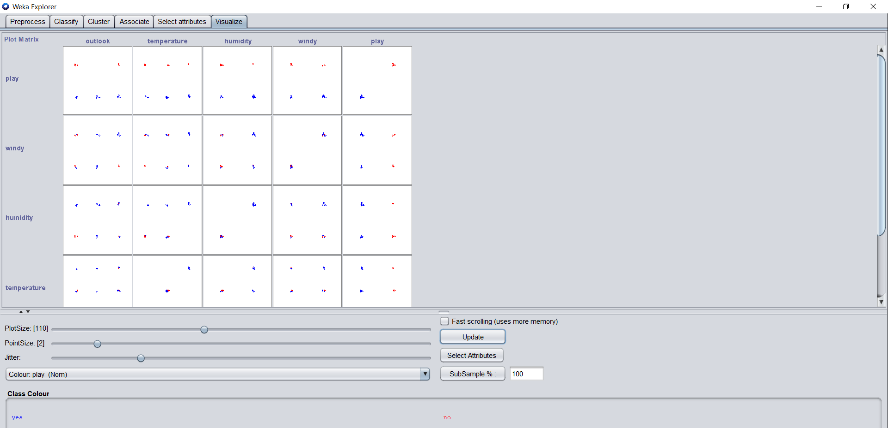

* **Screenshot of Weka Experimenter:**

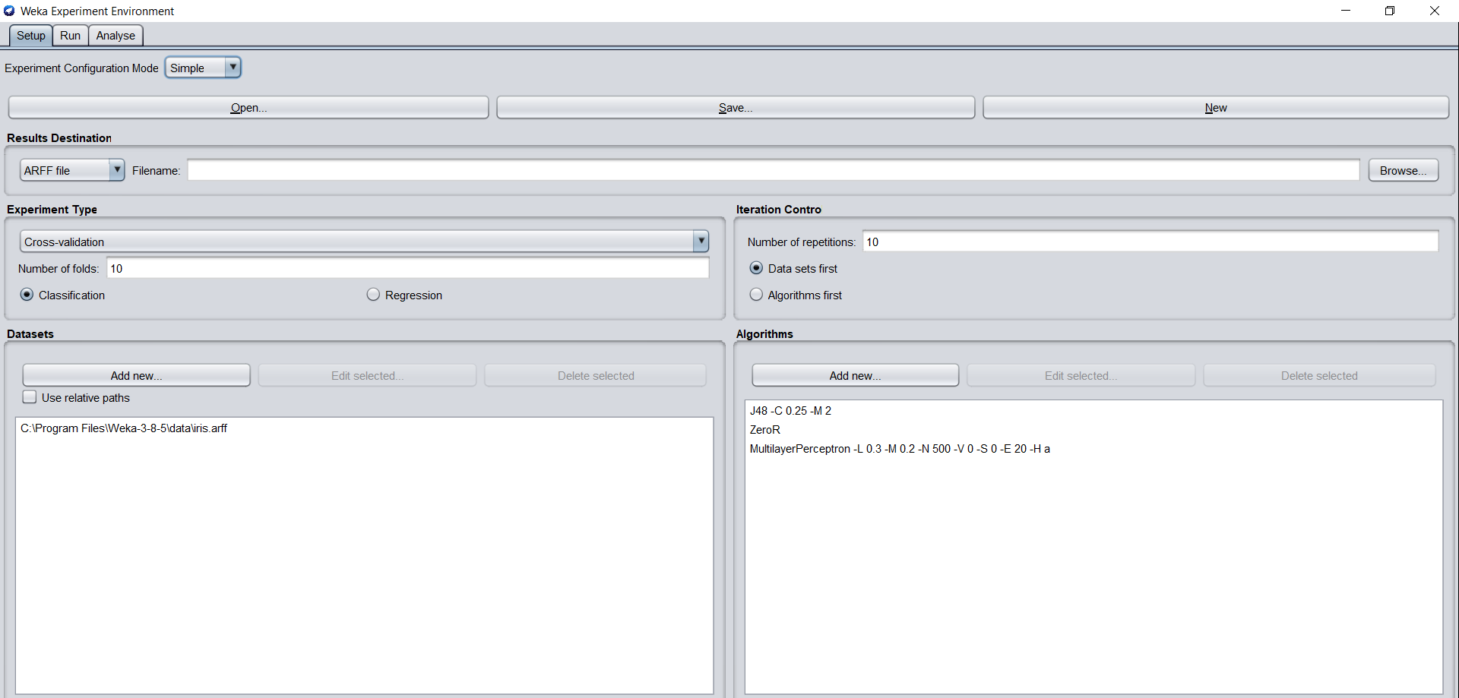

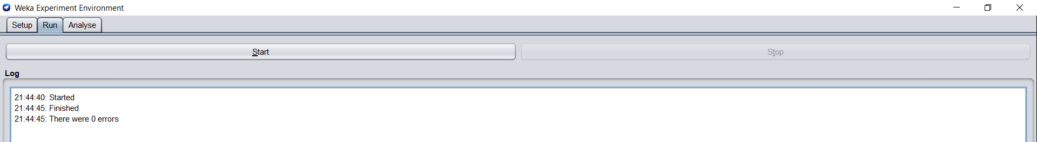

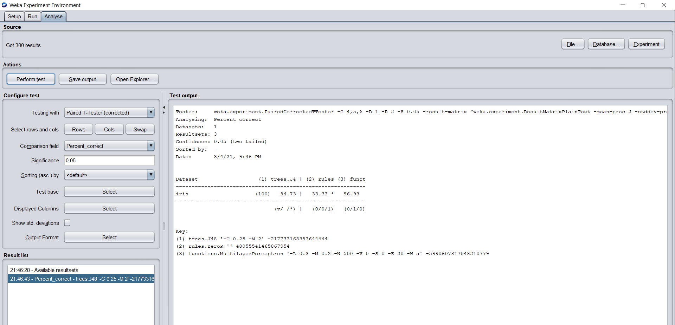

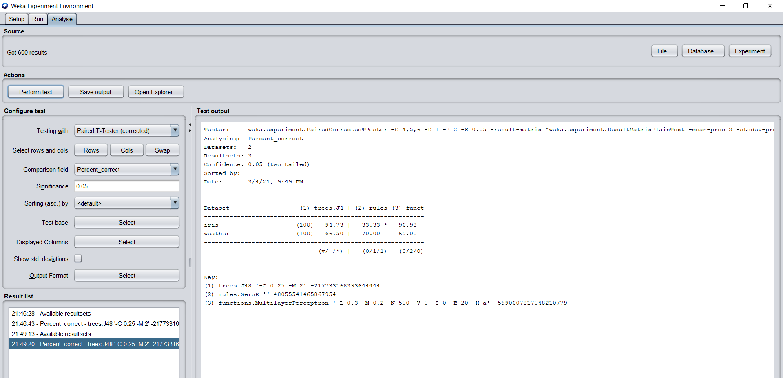

* **Screenshot of Weka Knowledge Flow:**

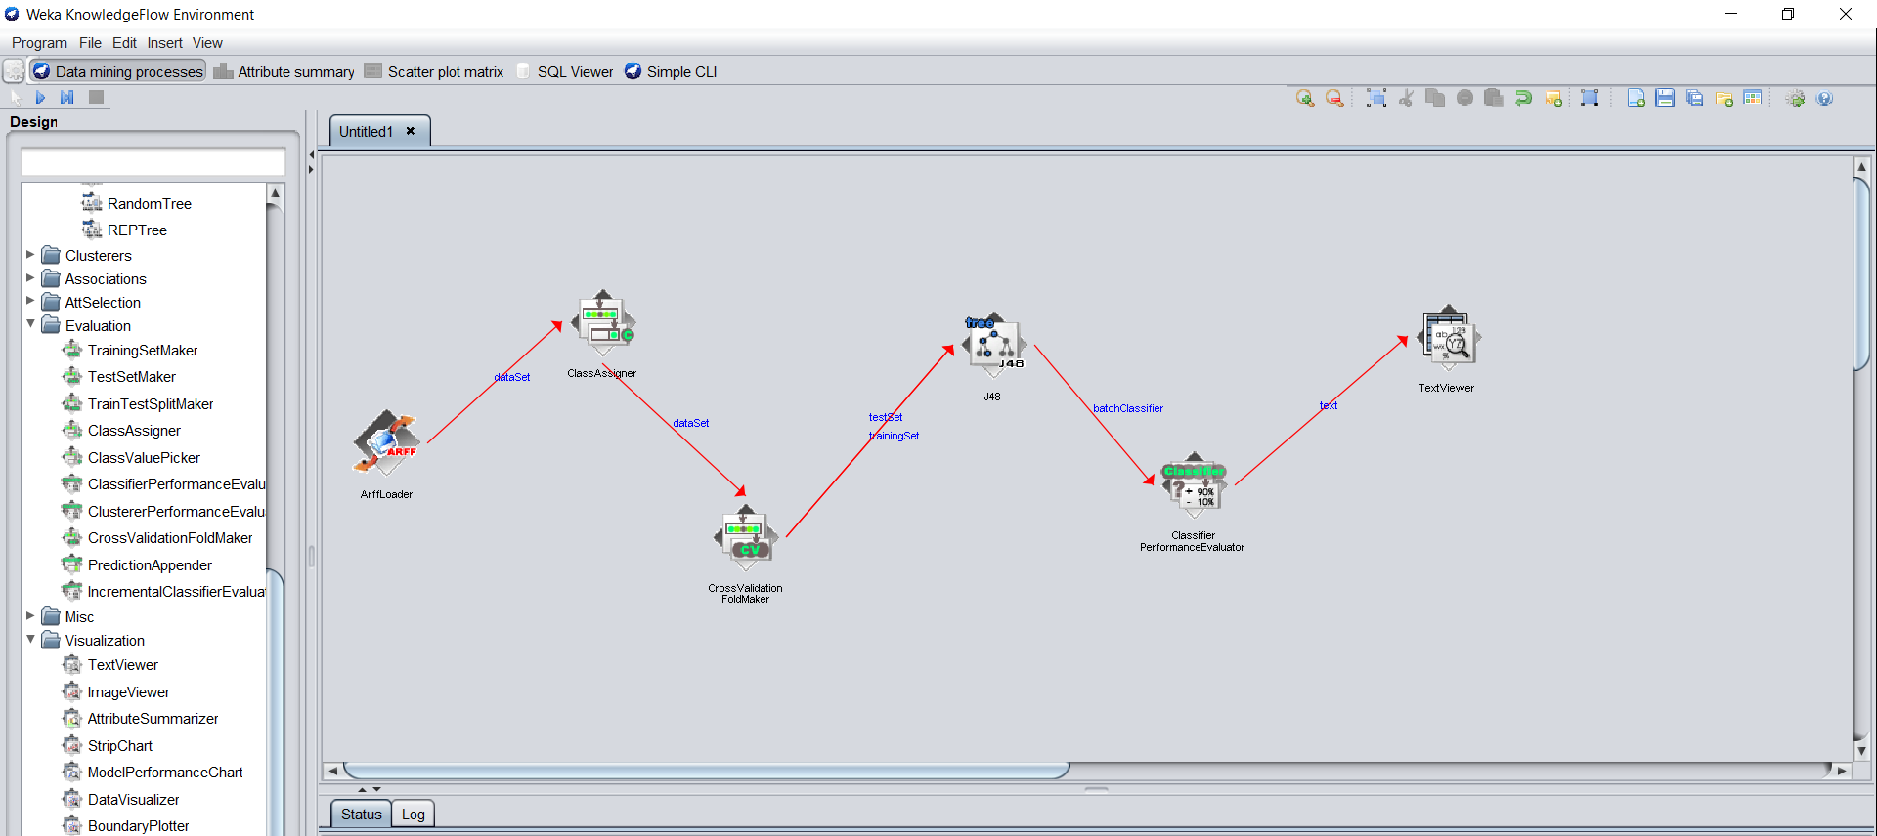

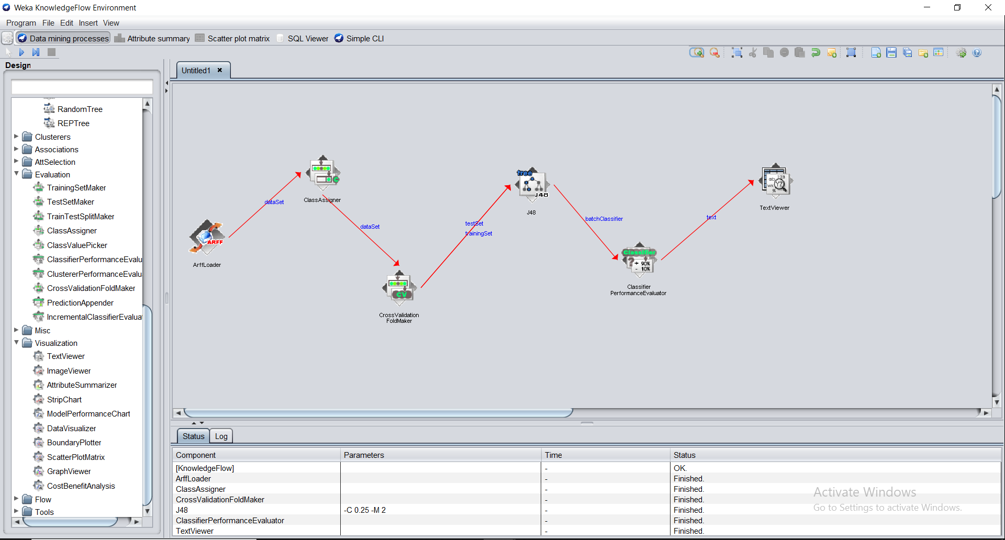

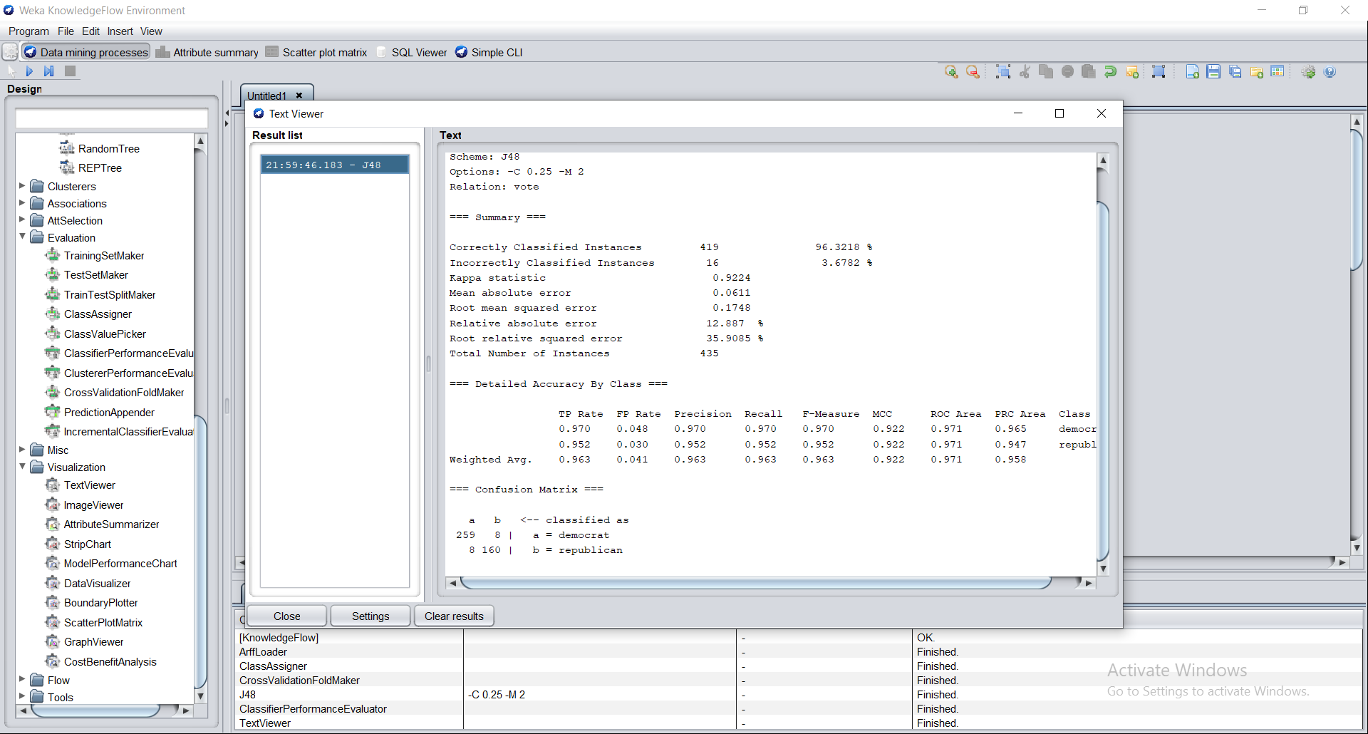

* **Reference link of web material**

<https://www.softwaretestinghelp.com/weka-tutorial/>

<https://machinelearningmastery.com/design-and-run-your-first-experiment-in-weka/>

<https://www.youtube.com/watch?v=m7kpIBGEdkI>

* **5 Question/Answers**

1. **What is Weka?**

Weka is a collection of machine learning algorithms for data mining tasks. The algorithms can either be applied directly to a dataset or called from your own Java code. Weka contains tools for data pre-processing, classification, regression, clustering, association rules, and visualization.

1. **What are the features of Weka?**

* **Open Source**: It is released as open source software under the GNU GPL. It is dual licensed and Pentaho Corporation owns the exclusive license to use the platform for business intelligence in their own product.
* **Graphical Interface**: It has a Graphical User Interface (GUI). This allows you to complete your machine learning projects without programming.
* **Command Line Interface**: All features of the software can used from the command line. This can be very useful for scripting large jobs.
* **Java API**: It is written in Java and provides a API that is well documented and promotes integration into your own applications. Note that the GNU GPL means that in turn your software would also have to be released as GPL.
* **Documentation**: There books, manuals, wikis and MOOC courses that can train you how to use the platform effectively.

1. **Is Weka good for machine learning?**

A big benefit of using the Weka platform is the large number of supported machine learning algorithms. The more algorithms that you can try on your problem the more you will learn about your problem and likely closer you will get to discovering the one or few algorithms that perform best.

* The different types of machine learning algorithms supported and key algorithms to try in Weka.
* How algorithms can be configured in Weka and how to save and load good algorithm configurations.
* How to learn more about the machine learning algorithms supported by Weka.

1. **How good is Weka?**

"Easy, Simple yet Powerful tool for data mining"  
  
**Weka** is easy to learn. I am using it for a year to solve data mining problems. I can directly fit the data to any machine learning algorithm available in **weka** which makes my job simple without worrying about coding.

### How do we use Weka to predict?

### Precisely you have to load the model file[saved in step 1] and then use the 'supplied test set" option on the "Classifiers" tab. In "supplied test set" option select the un-labelled data. More on this can be found here: http://weka.wikispaces.com/Making+predictions.

* **Conclusion**

From this practical we have learnt how to Weka Explorer, Weka Experimenter and Knowledge flow works on the given data set.

|  |  |  |  |
| --- | --- | --- | --- |
| **Prepared By:** | Rajiv Kumar Gupta (18CE137) | **Date:** | 04-04-2021 |